***Hands on 4***  
Spring Core – Load Country from Spring Configuration XML

◉ We’ll create:

* Country class with code & name, with constructor + setters/getters that log debug info.
* country.xml Spring configuration file with <bean> definition.
* SpringLearnApplication with displayCountry() method that loads the bean from XML and prints it.

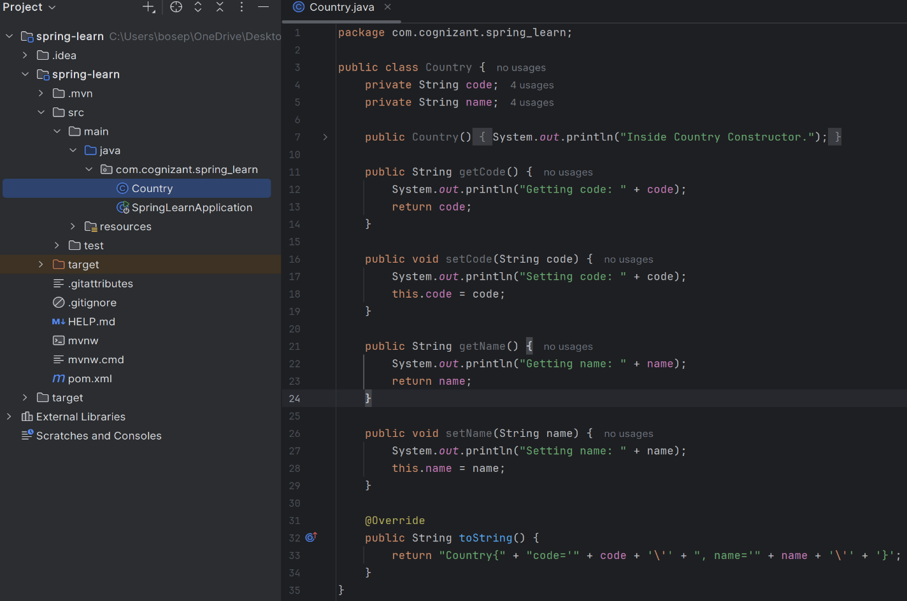**Step** **1**: Create the **Country class** (Country.java) in directory src/main/java/com/cognizant/springlearn/Country.java

**Step 2: Create the Spring XML configuration**

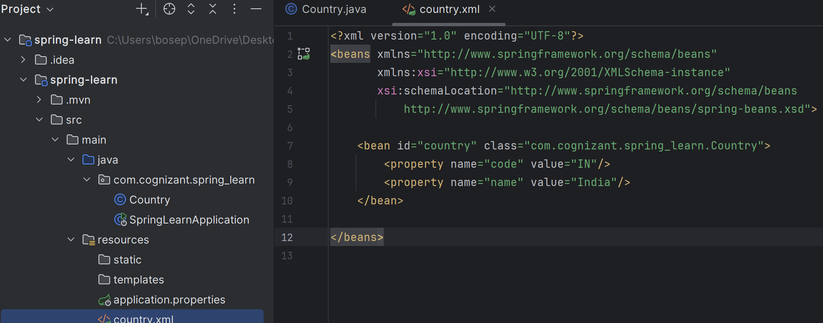

**Step 3**: Update **SpringLearnApplication.java**

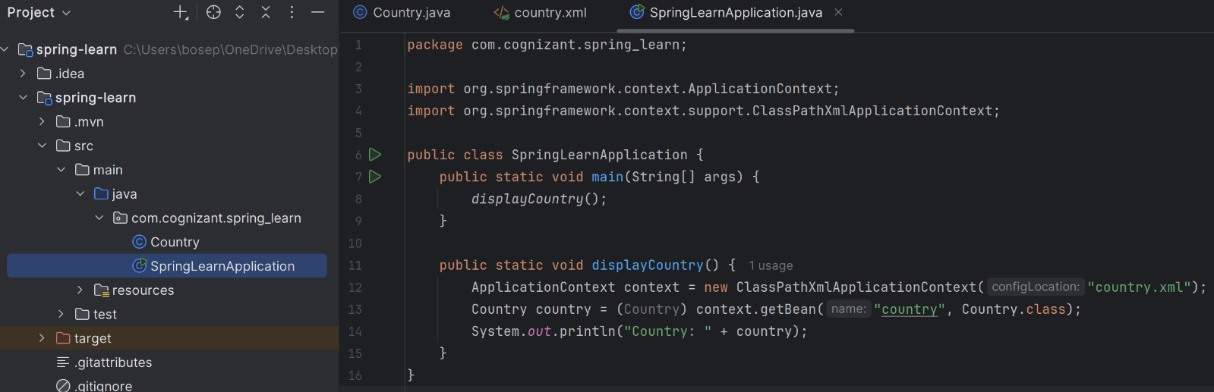**Step 4**: **Add Maven dependency** for **Spring Core**

**Step 5 : Run SpringLearnApplication.java ➜ Run 'main** & verify logs **(output):**

